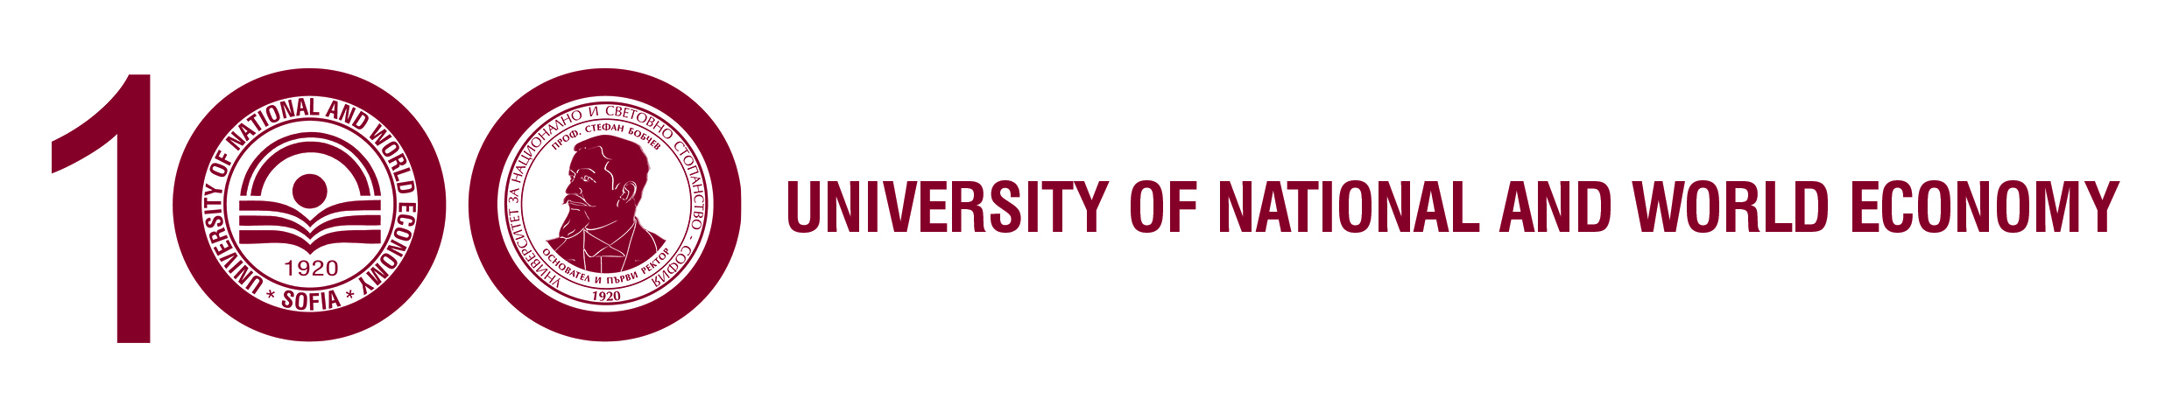

Faculty of International Economics and Politics
Department of Foreign Languages and Applied Linguistics

We have the honour and pleasure to invite you to the jubilee international scientific conference

“100 YEARS OF FOREIGN LANGUAGE EDUCATION AT UNWE: THE OUTLOOK FOR TOMORROW”

30 – 31 October 2020, UNWE

The conference aims at providing a venue for the discussion of topical issues related to the teaching of foreign languages for specific purposes, the role of information technologies in linguistic and literary research, the use of effective resources for online education in foreign languages, testing and assessment of foreign language knowledge and skills in traditional and online learning, presenting the results from university and international projects with the participation of lecturers from the Department of Foreign Languages and Applied Linguistics at UNWE, the importance of foreign language proficiency for economists, experts in international politics and economics, journalists, translation studies, consecutive and simultaneous interpretation, presenting the scientific and didactic production of the host department and the conference participants, etc.

Conference official languages: Bulgarian, English, Russian, Spanish, German and French.
Conference format: Speakers: 30-minute oral presentations
Non-speakers and speakers: participation in the conference discussions

IMPORTANT DATES

Deadline for submission of abstracts (of up to 100 words) and registration forms: 01.09.2020. Send to 100FLUNWE@gmail.com.

Notification of acceptance: 15.09.2020

Full paper submission: 15.12.2020
The authors of accepted abstracts may submit their full papers to be published in the conference proceedings or in the scientific journals of UNWE. The conference proceedings are with ISBN and are included in the National Reference List of Contemporary Bulgarian Scientific Publications with Scientific Review. Author’s guidelines will be sent with the notification of acceptance.

Conference fee: 50 lv. (€ 25) The conference fee includes attendance at the conference sessions, conference proceedings printed on a CD-Rom, printed materials, coffee breaks, conference reception, a certificate. All other conference-related expenses are covered by the participants or by the participant institution.
Conference fee payment: a bank transfer should be made by 26.10.2020 to:

Bank: Bulgarian National Bank
BIC: BNBGBGSD
IBAN: BG03 BNBG 9661 3100 1746 01 /UNWE bank account in BGN/
Reason for payment: Conference fee FLUNWE

A scanned copy of the payment document should be sent to 100FLUNWE@gmail.com.

Organising committee Scientific committee
Prof.Daniela Koch-Kozhuharova, PhD Prof. Daniela Koch-Kozhujarova, PhD
Assoc. Prof. Antonia Pencheva, Phd Assoc. Prof. Antonia Pencheva, Phd
Senior Lecturer Albena Stefanova, PhD Senior Lecturer Albena Stefanova, PhD
Senior Lecturer Kalina Bratanova, Phd Senior Lecturer Kalina Bratanova, PhD
Senior Lecturer Silvya Vassileva, PhD Senior Lecturer Silvya Vassileva, PhD
Senior Lecturer Lilya Gerdzhikova

